[Project Name]
  - Stakeholder Register

[Author Name]
[Company Name]

STRICTLY CONFIDENTIAL INFORMATION
Internal Use Only
This document is only to be issued following the receipt of the Non-Disclosure Agreement (NDA). This document may not be disclosed to any third party without the prior written authorization by [Company Name]. This document may only be disclosed to your offices and professional advisors in condition that they too agree to be bound by the terms of the NDA.

Document Purpose
The purpose of this document is to outline who the [Project Name] project stakeholders are, so that we can communicate with and appropriately engage with all stakeholders throughout the life of the project.

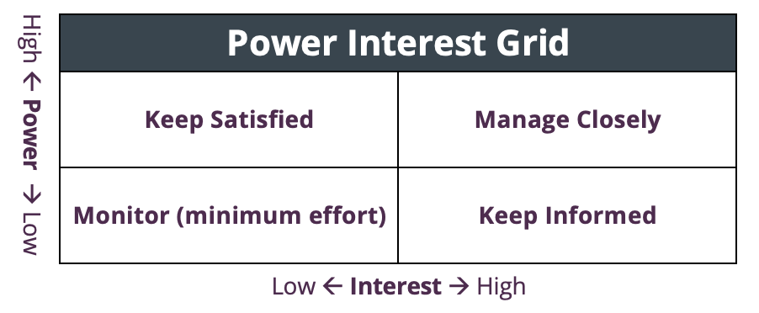
Definitions

- Stakeholder: A person with interest in the project results.
- Power: A stakeholder’s power can be high or low. They can have a positive or negative influence on the project.
- Interest: A stakeholder’s interest can be high or low. They may have a specific area of interest and participation.
Project role
- Main Point of Contact (POC): The main point of contact for the project team; project information flows through them.
- Responsible: The main person responsible for completing the work on the deliverables and project.
- Accountable: The person that reviews/approves deliverables; their feedback could change or pause the project.
- Consulted: A collaborator/contributor on the project; they review and share input on the deliverables and project.
- Informed: A person that stays in the loop on progress; they do not share input on deliverables or project.

Engagement
- Monitor (minimum effort): Engage with them minimally; monitor communication needs.
- Keep Informed: Keep them informed on project status.
- Keep Satisfied: Keep them informed on project status and collect their input on the deliverables and project.
- Manage Closely: Engage them in all project activities.

Employees
Name | Title | Contact | Power | Interest | Engagement | Project Role
Employee | Text | jane@email.com | High | High | Manage Closely | POC
Employee | Text | sam@email.com | Low | High | Keep Informed | Informed
Employee | Text | Text | Text | Text | Text | Text

Contractors
Name | Title | Contact | Power | Interest | Engagement | Project Role
Contractor | Text | john@email.com | High | High | Manage Closely | Responsible
Contractor | Text | Text | Text | Text | Text | Text

Client Stakeholders
Name | Title | Contact | Power | Interest | Engagement | Project Role
Client | Text | jim@email.com | High | Low | Keep Satisfied | Accountable
Client | Text | Text | Text | Text | Text | Text
Client | Text | Text | Text | Text | Text | Text

Other Stakeholders
Name | Title | Contact | Power | Interest | Engagement | Project Role
Name | Text | Text | Text | Text | Text | Text
Name | Text | Text | Text | Text | Text | Text

